
273/1
GEOGRAPHY
Paper 1
JULY/AUGUST 2023
2hours 30 minutes

MPISSHA JOINT MOCK EXAMINATION

Uganda Certificate of Education

GEOGRAPHY

Paper 1

2 hours 30minutes

INSTRUCTIONS TO CANDIDATES:
This paper consists of parts I and II.
Part I and Section A of part II are compulsory.
Answer only one question from section B of part II.
Answers to all questions must be written in the answer booklets provided

PART I
OBJECTIVE-TYPE QUESTIONS (30 MARKS)
These are 30 compulsory questions. Each question carries one mark.
Answers to this part must be written in the answer booklet provided.
1. Which one of the following areas in East Africa has sparse population?
A: Nebbi
B: Kisoro
C: Mwanza
D: Marsabit

2. Landslides are experienced around Mt. Elgon mainly due to?
A: Earth quakes
B: Heavy rainfall
C: Nature of the soil
D: Clearance of vegetation.

3. Which one of the following areas in East Africa receives orographic rainfall?
A: Tabora
B: Mwanza
C: Usambara
D: Dodoma

4. The arid conditions of North Eastern Kenya are mainly a result of?
A: the general flatness of the area
B: presence of thin vegetation cover
C: absence of large water bodies.
D: the North East trade winds.

5. Which one of the following features is found in the upper stage of a river
valley?
A: Bluffs
B: levees
C: meanders
D: pot – holes.

6. The major problem which has resulted from wildlife conservation on Mt. Elgon
is?
A: shortage of land
B: over grazing
C: soil erosion
D: destruction of crops

7. The development of steel industries in East Africa has been mainly limited by
A: small qualities of iron ore
B: low levels of technology
C: unskilled labour
D: unreliable power supply

8. Heavy engineering is poorly developed in East Africa mainly because of the
shortage of
A: skilled labour
B: capital
C: raw materials
D: power

9. Which one of the following is a glacial erosional landform?
A: cirque
B: stack
C: Arch
D: Bluff

10. Industrialization in Uganda can be best achieved by
A: training industrial workers.
B: improving the transport network
C: encouraging foreign investments
D: establishing industrial parks.

11. When sandstone is subjects to great heat and pressure, it is turned into
A: slate
B: gneiss
C: marble
D: quartzite

12. Which one of the following is a characteristic of sand soil?
A: red in colour
B: contains course grains
C: retain a lot of water
D: exist in layers.

13. Which one of the following is a horst mountain in East Africa?
A: Muhavura
B: longonot
C: Uluguru
D: Kilimangaro

14. In which one of the following areas in East Africa is limestone mined?
A: Webuye
B: Mwadui
C: Magadi
D: Athi river

15. Temperate vegetation in East Africa is found in the
A: highland
B: coastal areas
C: plateau
D: lake shore region

16. The semi arid climate in East Africa is characterized by
A: dense cloud cover.
B: heavy rainfall.
C: small diurnal temperature range
D: constant blowing winds

17. Which one of the following fishing methods is used for catching deep sea fish
A: purse – seining
B: Gill – netting
C: fish – traps
D: trawling

18. The major problem facing fishing on Lake George is
A: fluctuation in water level
B: limited market
C: hot temperatures
D: pollution from industries.

19. Which one of the following is lake tarn in East Africa?
A: Bunyonyi
B: Teleki
C: Rukwa
D: Katwe

20. The major contribution of National Parks to the surrounding communities in
East Africa is to
A: facilitate construction of schools
B: opening up remote areas
C: advertise local products abroad
D: avail income.

21. The major factor limiting the development of tourism in Uganda is
A: limited capital.
B: poor transport network.
C: political instability.
D: poaching of wildlife.

22. Water transport on lake Victoria is mainly faced with a problem of?
A: accidents
B: piracy
C: inadequate market
D: limited capital

23. The major cash crop grown in the kilomboro valley is
A: rice
B: sugarcane
C: tea
D: coffee

24. Sisal growing in Tanzania has been favoured by
A: high altitude
B: heavy rainfall
C: warm temperatures
D: fertile alluvial soils
25. Which one of the following weathering process is dorminant on top of Mt.
Kenya?
A: hydrolysis
B: hydration
C: oxidation
D: freeze - thaw

26. Which one of the following vegetation is found at an altitude of 3500 –
4500m a.s.l?
A: Savanna
B: Bamboo forest
C: heath and moorland
D: temperate forest

27. On which of the following lakes in Uganda is fish farming practiced?
A: Albert
B: Edward
C: Kyoga
D: Victoria

28. Coffee growing in the Kenya highlands is mainly favoured by
A: acidic soils
B: cool temperatures
C: heavy rainfall.
D: low incidence of diseases.

29. Congestion in Dodoma city has majorly resulted into a problem of
A: accidents
B: traffic jam
C: pollution
D: increased theft

30. Which one of the following is a major problem resulting from clay mining in
Lake Victoria shores?
A: flooding
B: accidents
C: pollution
D: deforestation

PART II
MAPWORK, PHOTOGRAPH INTERPRETATION, FIELDWORK, EAST AFRICA

1. COMPULSORY QUESTIONS: MAP WORK [20 MARKS
Answer all Parts of this questions.
Study the 1:50,000 (UGANDA) NYARWEYO MAP EXTRACT part of sheet 48/4,
series Y732, Edition 1 U.S.D and answer the questions that follow.

(a)(i) State the grid reference of the road Junction at Nyarweyo. [01 mark]
(ii) Name the drainage feature at 148245. [01 mark]

(b) Measure and state in kilometer the distance of the dry weather road from
Kadebede (GR 210246) to the culvert at Kadiki (GR 097336) [01 mark]

(c) Draw a Relief Section of the area along Easting, 20 between Northings 25
and 35 and on it mark and name:
- County boundary line. [01 mark]
- River Mpongo [01 mark]
- Forests [01 mark]
- Steep slope. [01 mark]
- Swamps [01 mark]

(d) Describe the:
(i) Relief of the area. [04 marks]

(ii) Relationship between relief and transport of the area shown on the
map. [04 marks]

2. COMPULSORY PHOTOGRAPH INTERPRETATION QUESTION
[15 MARKS]
Answer all Parts of this question.
Study the photograph below and answer the questions that follow.

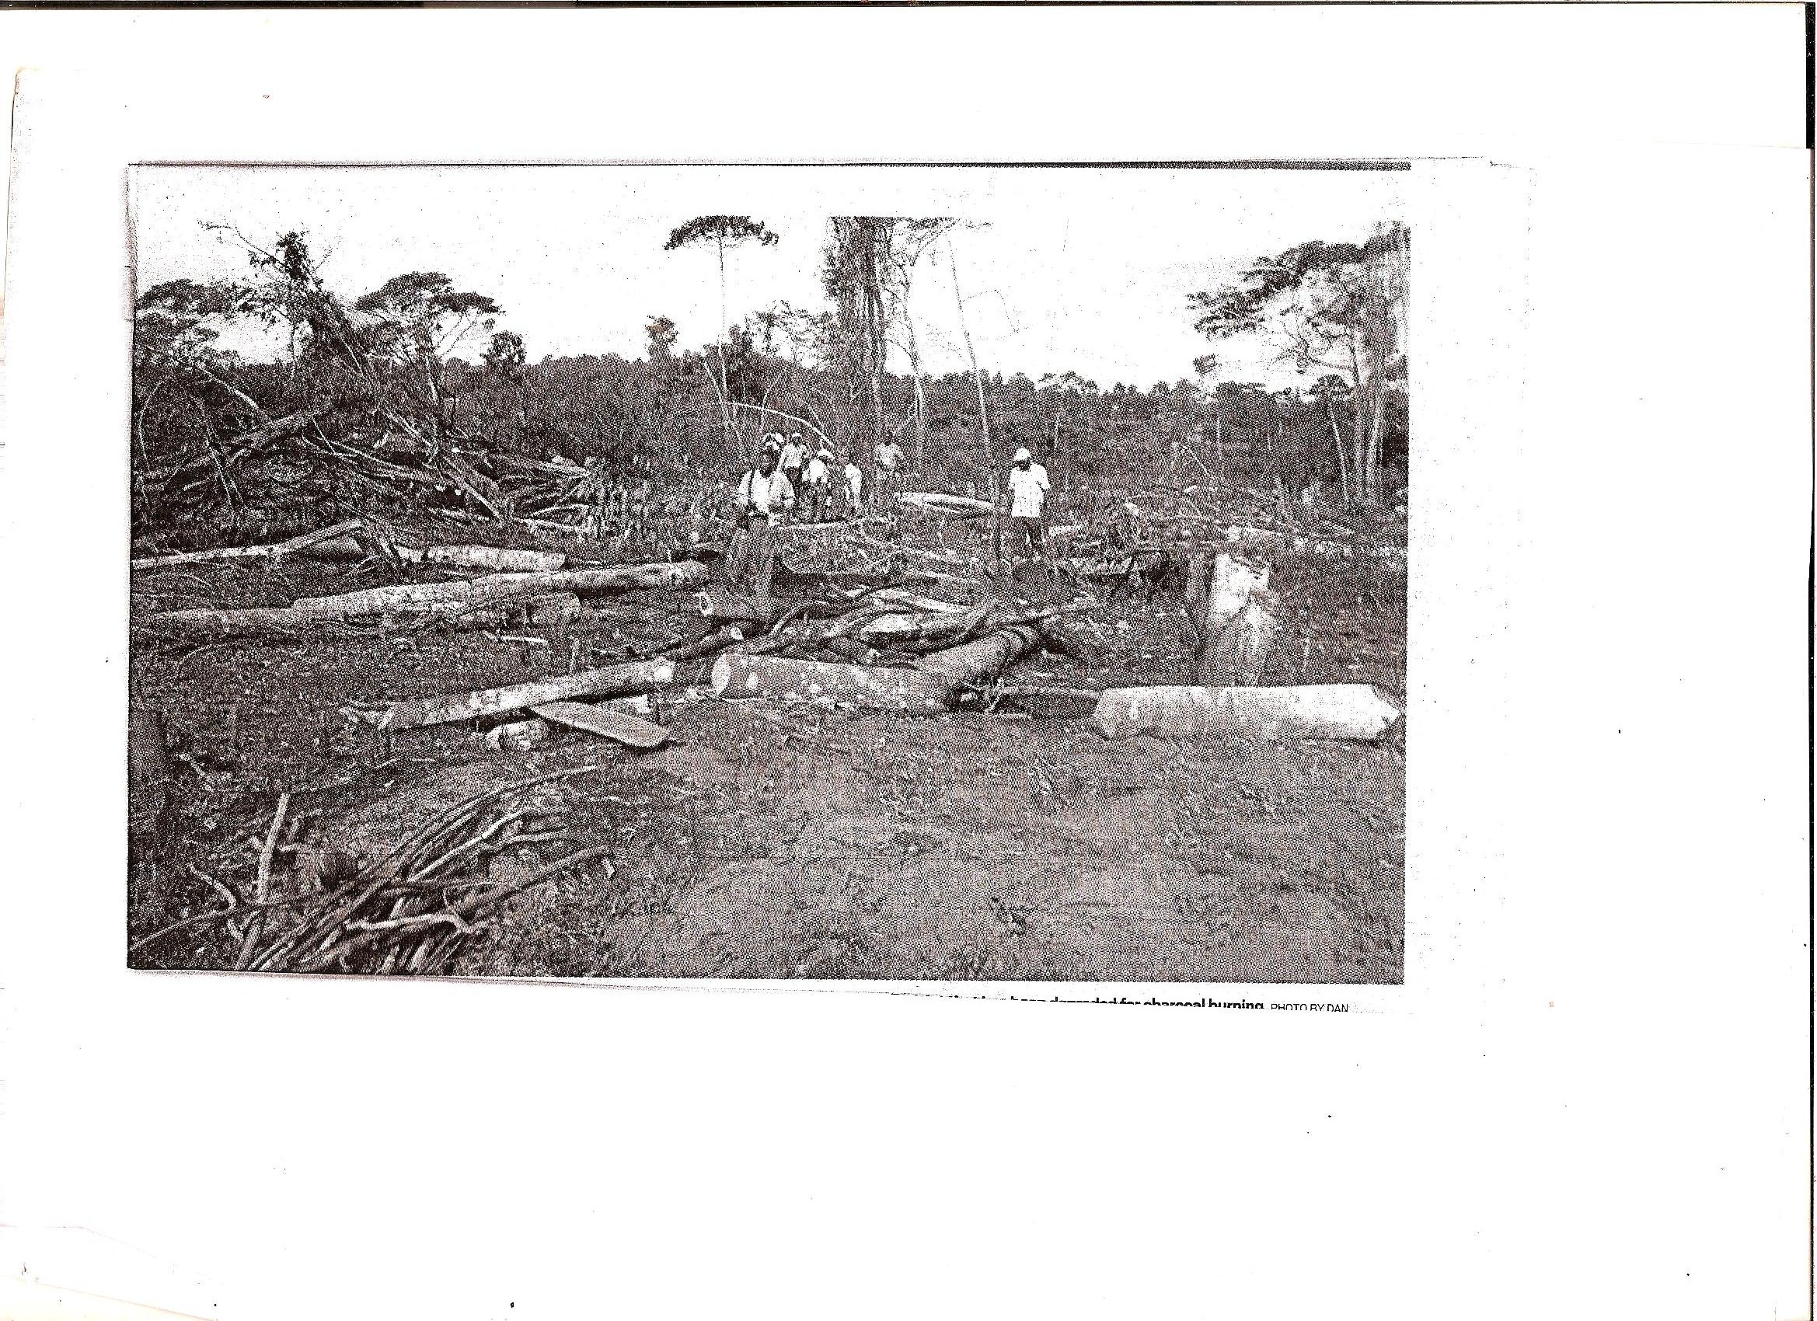
(a) Identify the activity taking place in the photograph. [01 mark]

(b) Draw a landscape sketch of the photograph and on it mark and name.
(i) Relief feature. [01 mark]
(ii) Forest [01 mark]
(iii) tree stumps [01 mark]

(c) Explain the problems faced by the people carrying out the activity identified
in (a) above. [04 marks]

(d) (i) Explain the effects of the activity on the environment. [04 marks]

(ii) Giving reasons for your answer, suggest an area in East Africa where this
Photograph could have been taken. [01 mark]

SECTION B : EAST AFRICA [20 MARKS]
Answer only one question from this Section.
4. (a) Draw a sketch map of East Africa and on it, mark and name:
(i) the East African Rift – valley,
(ii) Lakes: Albert and Rukwa.
(iii) Mountains: Nyiru, Pare. [08 marks]

(b) Describe the processes that led to the formation of either the East African
Rift – valley OR Block Mountain in (a) above. [04 marks]

(c) Explain the value of mountains to the people of East Africa. [04 marks]

(d) Explain the problems faced by people living in the Rift – valley areas. [04 marks]

5. Study the table below showing Uganda’s export crops (2002 – 2003)
in metric tonnes and answer the questions that follow:

Export crop | Metric tonnes (2002) | Metric tonnes (2003)
Coffee  Cotton  Tea  Sugar  Tobacco  Cocoa | 201,000  5,000  30,000  1,000  229,000  2,000 | 40,000  2,000  8,000  000  77,000  1,000
Adapted: 2005 African Development Indicators
The world Bank Pg. 92 – 100

- Identify the:
- Leading,
- Lowest
Export crop from Uganda in 2002. [02 marks]

- Calculator the percentage change of each export between 2002 and 2003. [03 marks]

- Draw a bar graph to show Uganda’s export crops for 2003. [06 marks]

- (i) Explain the problem of over-depending on agriculture exports.
[05 marks]
(ii) Outline the steps being taken to solve the problems in (d) (i) above.
[04 marks]

6. (a) Describe the vegetation zonation on any one mountain in East Africa
basing on altitude.

(b) Describe the factors which have influenced the distribution of forests in
East Africa. [06 marks]

(c) Explain the importance of forestry resources to any one country in East
Africa. [04 marks]

(d) Outline the problems facing the forestry industry in any one country
chosen in (c) above. [04 marks]

7. Draw a sketch map of East Africa and on it mark and name
(i) Towns : Mbale, Tanga& Mombasa
(ii) Lakes : Malawi and Rudolf
(iii) Rivers : Turkwel and Rufigi. [09 marks]

(b) Name three industries found in any
(i) One towns identified in a(i) above. [03 marks]

(ii) Describe the factors which have favoured the development of industries in
any one industrial town identified in a(i) above. [03 marks]

(c) Explain the problems resulting from industrial development in East Africa.
[03 marks]
(d) Name any other two industrial towns in East Africa. [02 marks]

